Updates and Corrections on the Website
Update 1: New Logo to be updated
Logo file given as PNG
Update 2: Contact Page : Connect to the Mail repository
Update 3: Add a button to the right corner of the page to go to the home page like the balloon logo something creative
Update 4: Add Content on to the footer
Reference Image
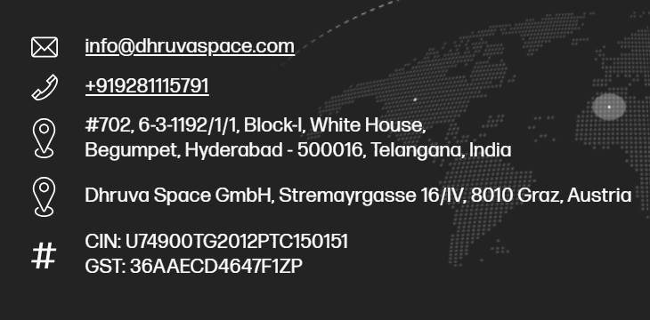
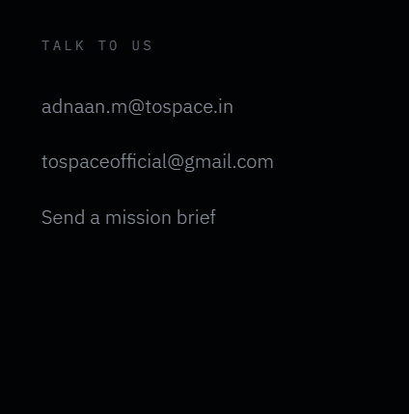
+91 93618 54814
M114, Mullai Street, North Gandhigramam, Karur 639004, Tamil Nadu, India
No. 23, 2nd Floor, Palandiamman Koil Street, Adambakkam, Chennai 600088, Tamil Nadu, India
CIN: U29291TN2021PTC146836
GSTIN: 33AAICT9147N1ZP
Corrections 1: Website is not reactive to all size of the computer screen (Not Fitting)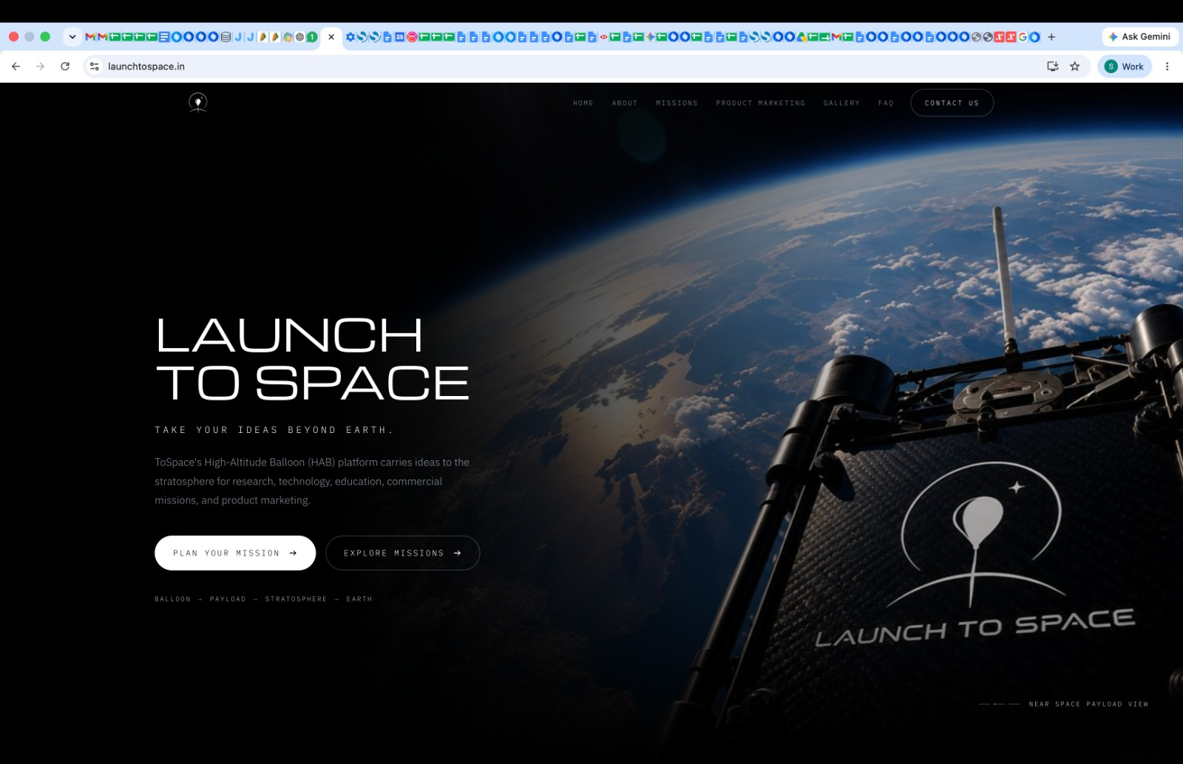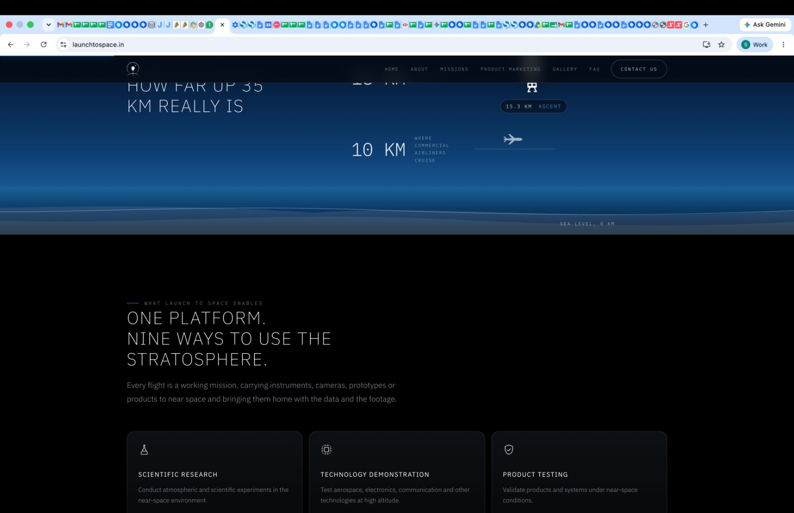
Corrections 2: This content is not centre aligned 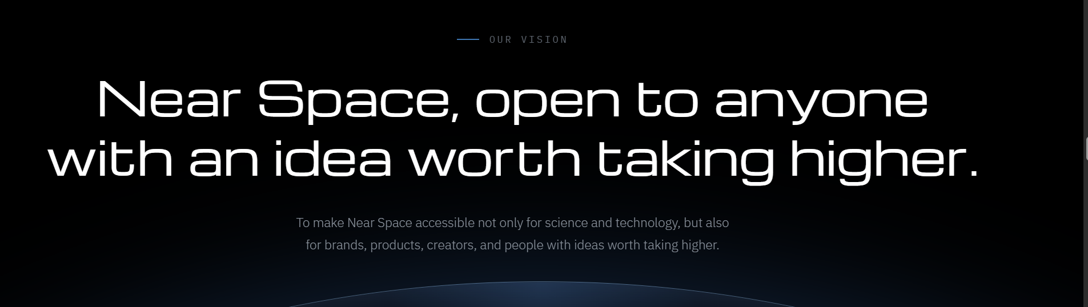
Correction 3: Footer line is not connected to the full end like the header
Correction 4: Privacy Policy Cookie Policy Legal Notice Terms & Conditions and these four page font are completely different from the main page
Correction 5: Remove the Word Payloads
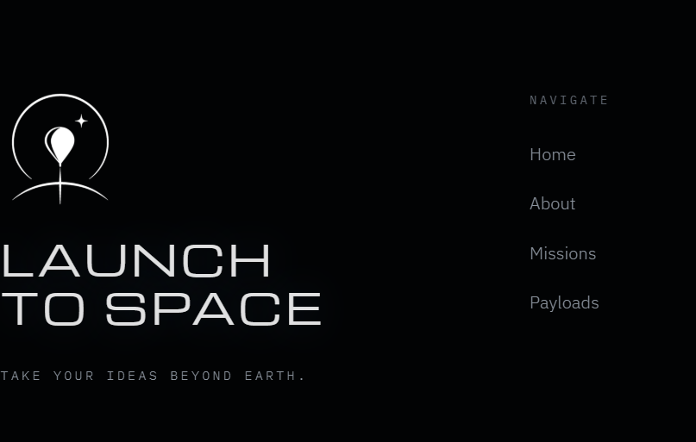
Correction 6: FAQ: Changed the content
How long does a mission take, and how do I start one?
Send us a short brief with what you want to fly, what you want back, and roughly when. Once we have your proposed launch location, we assess regulatory compliance and flight feasibility and respond within two working days with a mission plan, a payload checklist and a quote. From there, planning and payload integration typically take four to six weeks. The flight itself runs 2–4 hours from release to recovery, and edited content is delivered about ten days after landing.
Correction 7: Change the Working days on the contact page
REPLY WITHIN 2 WORKING DAYS
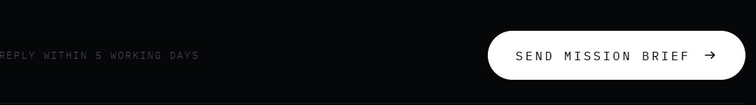
Correction 8: Change Range / Line of Sight to Downrange Drift
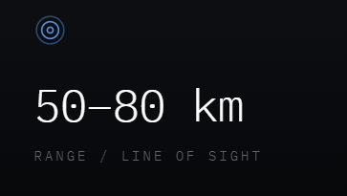
Correction 9: Change as Up to 5 Kg
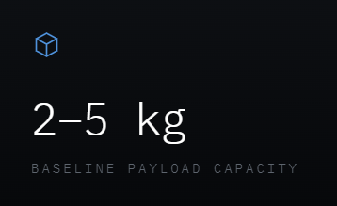
Correction10: FAQ: Changed the content
Are these HAB launches legally authorised?
Yes. We file for and obtain the required clearances from DGCA and the relevant local authorities for every launch, covering both the flight and your payload. You do not deal with the paperwork. Where a proposed site cannot be cleared, we identify a workable alternative with you before the mission is scheduled.
Correction11: FAQ: Changed the content
How is the payload recovered, and what if recovery fails?
In the rare event that a payload cannot be recovered, we fly a replacement mission at no additional launch cost, subject to the re-flight terms in our mission agreement.

Correction12: Move to next line ( the stratosphere should be in a same line.)
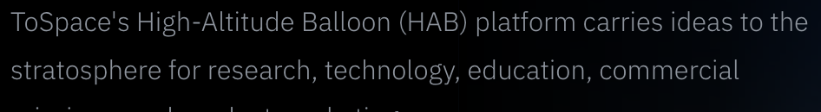
Correction13: Move to next line - (35KM should be in the same line)
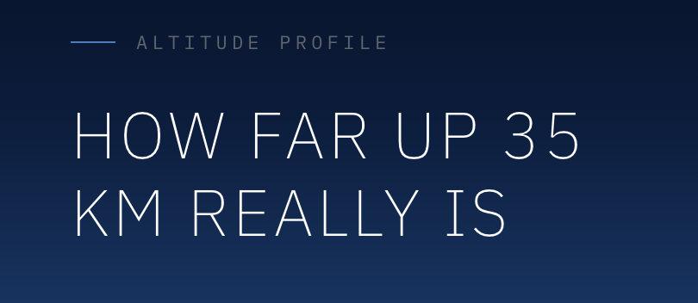

Correction14: Need to change the title
ONE PLATFORM.
NINE WAYS TO EXPLORE
THE STRATOSPHERE.
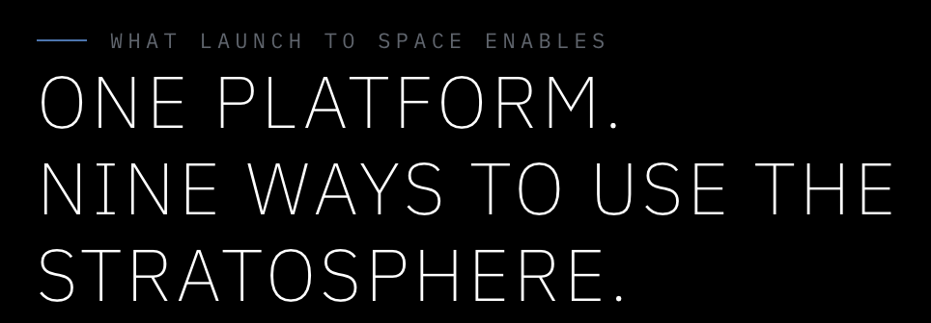

Correction15: Add - instead of comma (Every flight is a working mission – carrying instruments, cameras, prototypes, and products to near space, then bringing them back with the data and footage captured along the way.)
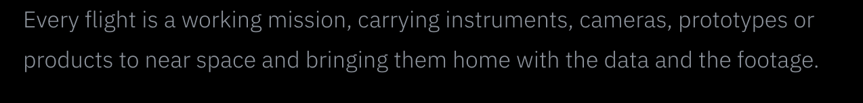
Correction16: move near to the second line (near – space should be in the same line)
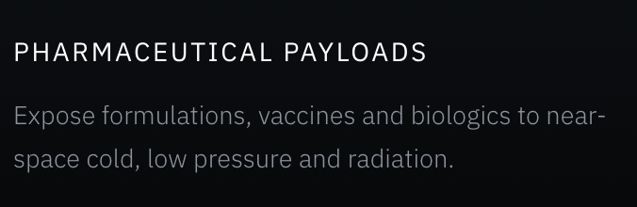

Correction17: Change to - Your product. Our mission. The edge of space.


Correction18: move “all of” to second line (“all of them”)
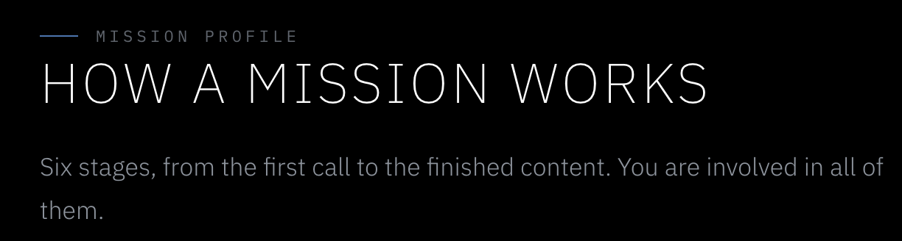

Correction19: move near to the second line (near – space should be in the same line)
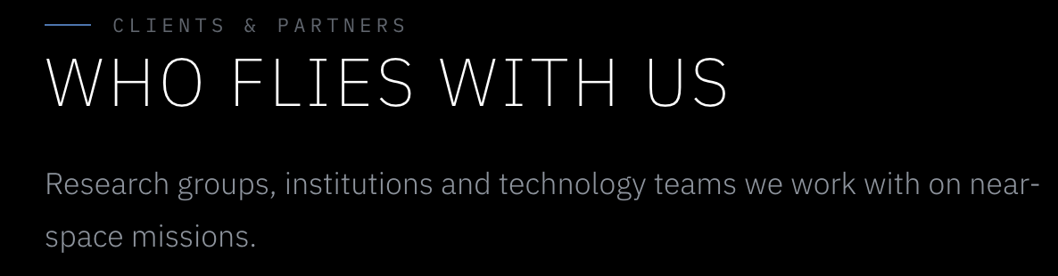

Correction20: Replace this one
Line 1: Launch To Space is the High-Altitude Balloon platform built by ToSpace to make Near Space something you can actually reach, without waiting a decade or paying for a rocket.
Line 2: A high-altitude balloon can carry a well-built payload to 30–35 km, hold it there while cameras capture the journey and instruments collect data, and bring it back the same day. From that altitude, you can see Earth’s curvature, the darkness of space above the atmosphere, and how your hardware performs in an environment unlike anything on the ground.
Line 3: We handle the full flight balloon, carrier, tracking, recovery and mission operations.
Line 4: You bring the idea. We’ll take it beyond Earth.
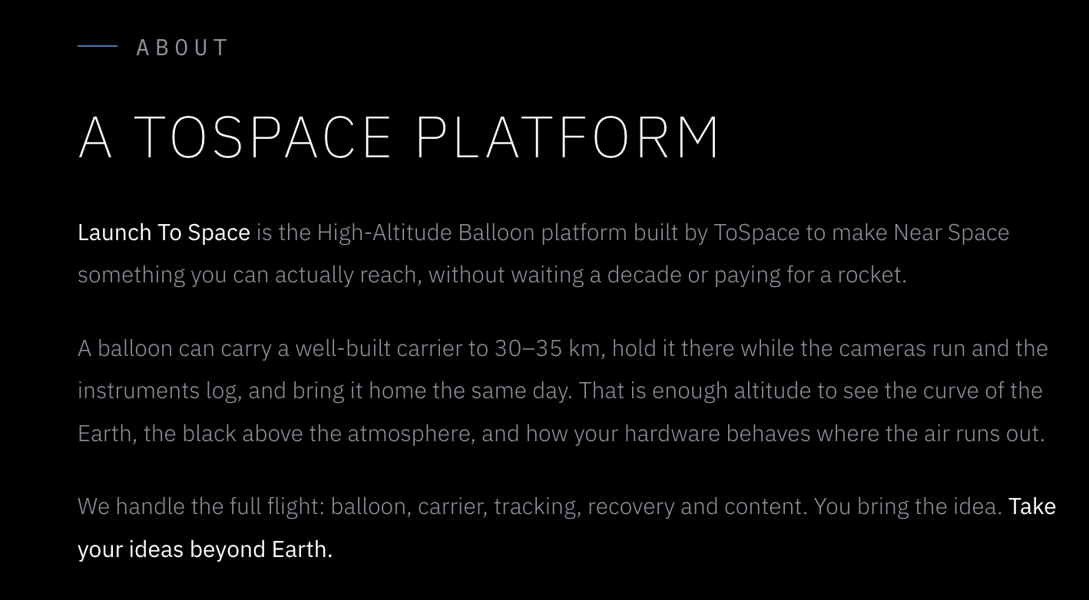

Correction21: “Your next mission could begin at the edge of space.” changeto
“Bring us your idea, and let’s take it higher.”
Correction22: Remove “Plan your mission” and “contact us” button
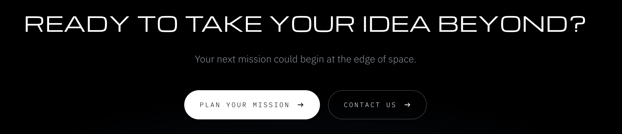

Correction23: “Send Mission Brief” opens the system email instead of chrome Gmail.
Correction24: The text area should not be manually resizable. Please disable the resize/drag handle in the bottom-right corner and keep the text area at a fixed size.
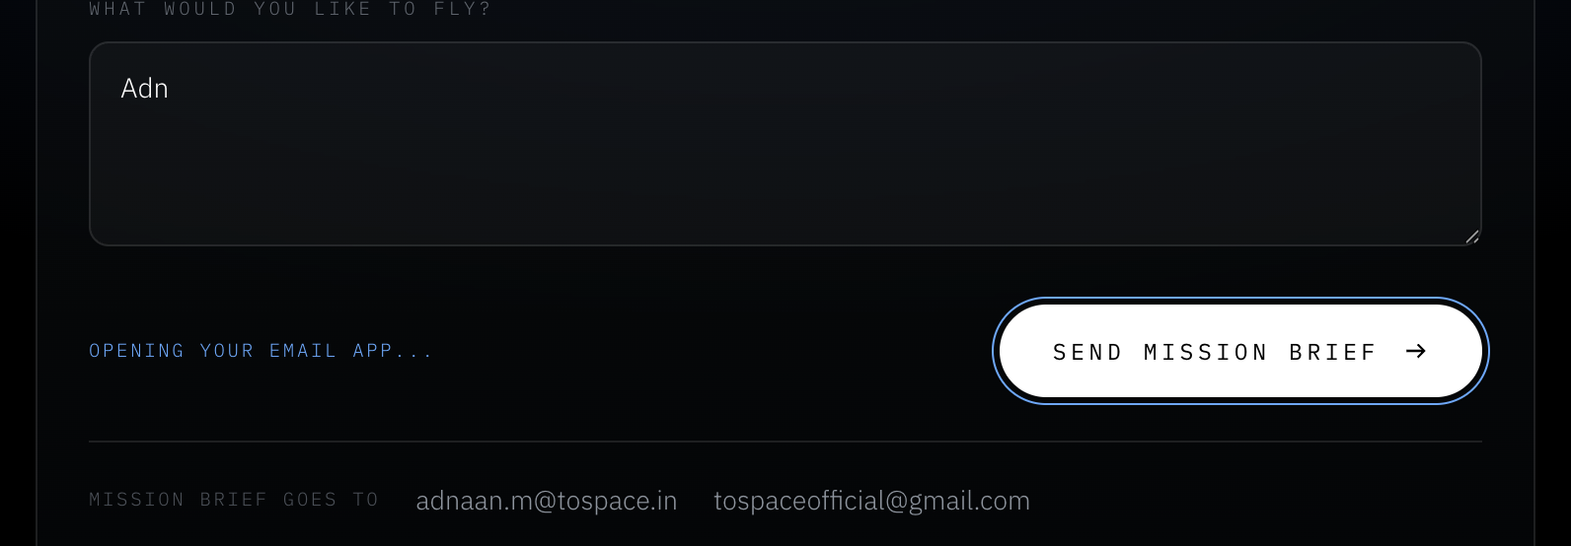
Correction25: Add email Icon for emails
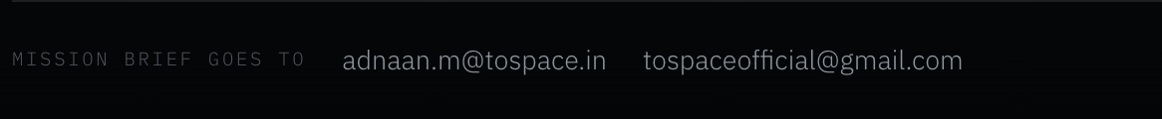

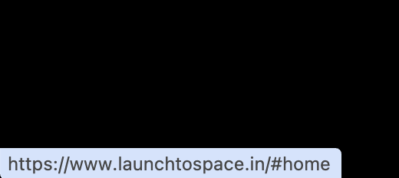
Correction26: Hide pop-ups - whenever I hover over the page links it appears

Correction27: [Send a mission brief →] - Highlight this one
Correction28: Replace - More as Explore
Correction29: Remove Contact in more column
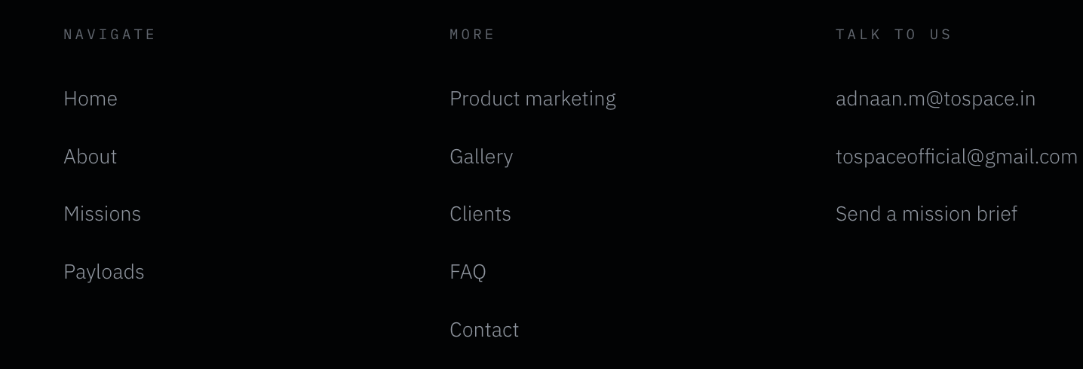
Correction30: © 2026 ToSpace Pvt Ltd - © icon is too small
Correction31: Privacy Policy · Cookie Policy · Legal Notice · Terms & Conditions - Looks empty. Add something like dot between these.

Correction32: When clicking a page link, an unwanted space is visible at the top of the page.
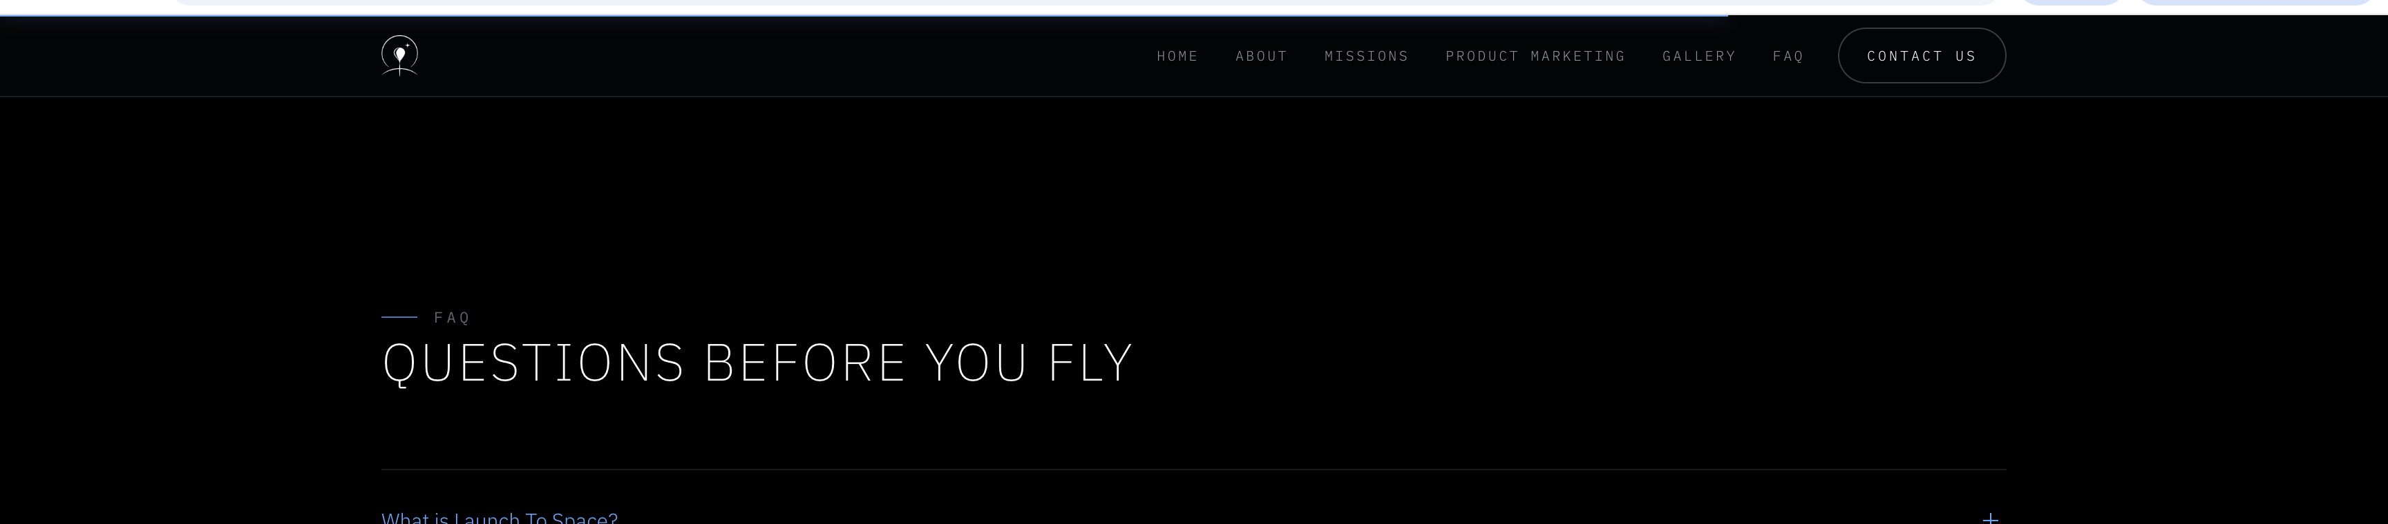

Correction33: Footer hides the logo page. Black colour background looks odd, can we have a transparent background for the last page.


